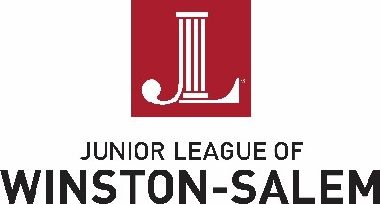

2019-2020 New Member Snapshot

Quarterly New Member Meetings (NMMs)

Get to know the League and each other! These meetings are specifically for New Members to learn more about the League and its initiatives through presentations by active members as well as community partners.

Quarterly General Membership Meetings (GMMs)

League-wide meetings for all Members (New, Active, and Sustaining) – At these meetings, you will hear League updates and announcements, vote on League initiatives, as well as have leadership training opportunities through guest speaker presentations.

New Member Socials

Monthly events that allow you the opportunity to build deeper relationships with other New Members in a more casual, social setting.

Community Involvement and In-League Involvement Opportunities

BookWORM, a drive to collect new and gently used children's books from its members and the greater community. The JLWS has collected and distributed over 10,000 children's books in the Forsyth County community in its first two years!

Strong Women. Strong Families. We strive to improve the health profile of the community concentrating on Kimberley Park Elementary School. Through our health and nutrition, the JLWS aims to facilitate relationships with local medical resources, educate participants on healthy nutrition, and provide a meal.

Puppet Show – Since 1986, the JLWS has presented a live puppet show to all third graders in the Winston-Salem Forsyth County Schools addressing the issues of child abuse, neglect and internet safety. This initiative empowers children with the knowledge of what to do in these situations and encourages students to talk with a trusted adult.
In-League Involvement Opportunities

Tour of Fine Spaces. The JLWS relies on two significant fundraisers to raise much needed funds to support our work in the community. The planning committee works with local contractors/designers to show off their handy work as clients invite you into their homes. Taking place in the Spring, this particular fundraiser allows attendees to peruse recently renovated/built homes while enjoying local fare from around town.

